Initial Project Proposal

Year: 2021 Semester: Fall Project Name: RevEx

Creation Date: April 10, 2021 Last Modified: June 14, 2021

Team Members (#1 is Team Leader):

Member 1: Matthew Rumple Email: rumple0@purdue.edu

Member 2: Isaac Hagedorn Email: ihagedo@purdue.edu

Member 3: Zach Ghera Email: zghera@purdue.edu

Member 4: Swagat Bhattacharyya Email: bhatta21@purdue.edu

1.0 Description of Problem:

Immersive virtual reality (VR) is the focus of a current engineering grand challenge: Enhance Virtual Reality. Beyond recreation, VR simulations are becoming increasingly important for occupational training, especially in remote or high-risk occupations. VR simulations usually allow the user to interact with virtual objects via camera-based appendage tracking, which is generally imprecise and has positional jitter. Hence, there is a need to more accurately track a user’s appendages for a more realistic simulation of the user’s motions in a virtual environment. Haptic feedback in virtual reality has countless applications in the future from training for many hands-on occupations to gaming with realistic environmental feedback; however, more current VR simulations do not provide enough haptic feedback and preexisting VR simulators with haptic feedback are overly expensive and too bulky to allow fluid movement. These limitations have stunted the growth of the VR training and recreational communities substantially.

2.0 Proposed Solution:

We seek to design a non-optical virtual reality input device with haptic feedback that creates a more immersive VR. Our design features a sophisticated haptic feedback system based on dynamic regenerative braking (see Appendix B for a detailed regenerative braking feasibility analysis).

In the occupational training use case, any interaction or collision with an object in the “VR world” would generate haptic feedback. In practice, the microcontroller creates haptic feedback by applying an electrical load across a generator. In this way, a generator can act like a passive electromechanical dampener. Part of the energy taken into the electrical load would be used to partially recharge the system’s batteries, and any excess energy would be dissipated as heat. The objective is not to completely meet the system’s power demand via regenerative braking, but rather to supply roughly 10% of the system’s mean power demand in a typical use case.

Our overall system would consist of a few sensor nodes (one per joint), each consisting of a small microcontroller and various sensors like potentiometers and IMUs to detect user movements. These nodes would share a common I2C bus with a central node that supplies power to the rest of the exoskeletal system and relays user movements to the host computer via bluetooth. The rationale to use a microcontroller at each sensor node as opposed to a single microcontroller connected to a sensor array is twofold:

* *Local processing:* Local pre-processing of sensor data diminishes the workload of the central node, which will be heavily engaged with communication between a host computer and the sensor nodes in the exoskeleton.
* *Modularization/Extensibility:* The minimum viable product of the system will consist of a sensor node on the elbow joint of each arm and the central (bluetooth and power) node. Once the proof-of-concept (POC) system consisting of three microcontrollers and a few PCBs is successful, the system can be readily expanded by adding sensor nodes at other joints on the body and simply connecting the new node to the common I2C line. This multi-node exoskeleton also provides benefits for potential consumers, allowing them to purchase as many nodes as needed for their use case.

The host computer will be running the VR simulation. A collision detection program running in the VR simulation will then determine and relay haptic feedback information back to the exoskeletal system. Each node would have a low-power analog event detector to generate wakeup interrupts only when the user is actively moving to lower microcontroller power draw. In this way, we hope to lower the overall power draw of the sensor nodes to a level sustainable via regenerative braking so that the proposed system can be worn for extended periods.

3.0 ECE477 Course Requirements Satisfaction

3.1 Expected Microcontroller Responsibilities

Each sensor node will contain a low-power microcontroller (STM32L0) to lower the overall communication overhead by locally processing data and generating only relevant data packets. The microcontroller(s) have several functionalities, including handling inter-node communication (using I2C), controlling the haptic feedback motor (using either a DAC or PWM depending on the braking mode), processing analog sensor data (using an ADC), reading from an IMU (using SPI), and communicating with a host computer/base station (using UART communication with a bluetooth chip).

3.2 Expected Printed Circuit Responsibilities

There will be three PCBs in our project (i-iii). Their functionalities are summarized below:

*(i). Central [Bluetooth and Power] Node:* This PCB will contain our bluetooth chip and a microcontroller that can grab packets from the I2C bus and format them to UART for the bluetooth chip. This PCB will contain a battery, a battery charging circuit, a supercapacitor (connected to regenerative braking boards), and a 1.8 V regulator (to power general-purpose sensor nodes).

*(ii). General-Purpose Sensor Node:* This PCB will contain a low-power microcontroller (STM32L0) to interface with peripherals (such as potentiometers and IMUs), an analog filterbank (for antialiasing before the ADC), and a low-power analog event detector (to generate a wakeup interrupt for the microcontroller when nonstationary sensor signals are detected). This design lowers overall system power draw.

*(iii). Haptic Feedback and Regenerative Braking Board:* This PCB will interface with a stepper motor. This board will have analog switches to either disengage the motor coil, energize the motor coil (to completely prevent motor movement), or harvest energy from the motor (to apply dampening/feedback and charge the battery). A boost converter circuit will be used to energize motor coils. Energy harvesting will be accomplished with a regenerative braking circuit controlled by the microcontroller.

See Appendix A for a concept sketch of the integration of each PCB in the overall system.

4.0 Market Analysis:

The target market includes both professional and recreational VR consumers. With an expanding number of companies looking towards VR-based job training in the post-COVID-19 age, improved haptic feedback and more precise user input will become increasingly important. Our system could meet this demand by providing both joint data acquisition as well as haptic feedback to users in VR. According to Redshift [1], the market for VR/AR based occupational training will be $8.5 billion by 2023. Besides VR training programs, the overall market for VR immersion technology, currently at $16.8 billion, is also on the rise. Much of the VR market is driven by the video gaming community. Many are purchasing VR headsets due to their significant price drop over the last few years. Unfortunately, there are no inexpensive, precise haptic feedback devices available to consumers. Our project would provide a non-optical solution to this problem, unlike most VR input devices today. The inexpensive system would break the monetary barrier between company and consumer budgets of haptic feedback and non-optical precise input devices for virtual reality.

5.0 Competitive Analysis:

There are several different haptic feedback systems for virtual reality that exist today for various possible sensory events.

5.1 Preliminary Patent Analysis:

5.1.1 US Patent Application US20170181916A1

**Patent Title**: “Exoskeleton suit with hand control to enable walking”

**Patent Holder**: Genesis Robotics and Motion Technologies Canada ULC

**Patent Filing Date**: May 5th, 2015

This patent [4] pertains to an exoskeleton that uses haptic feedback control to allow the user to move their legs via arm movements. The exoskeleton monitors the forces and angular movements of the arms and applies haptic feedback to the legs through actuators. The sensors on the exoskeleton are capable of detecting pitch, roll, and yaw of the arm and translates these motions into the proper feedback for the leg control unit.

5.1.3 US Patent Application US20160259417A1

**Patent Title**: “Hand exoskeleton for feedback system”

**Patent Holder**: Shenzhen Dexta Robotics Co Ltd

**Patent Filing Date**: May 16th, 2016

This patent [5] pertains to a haptic feedback exoskeleton for the hand that provides haptic feedback for the fingers through resistive forces. The exoskeleton monitors and measures finger joint movements, translates them to a corresponding position and velocity in the xyz plane, and then uses motor controllers to generate opposing forces using the estimated finger position and velocity.

5.2 Commercial Product Analysis:

5.2.1 Antilatency tracking System for VR/AR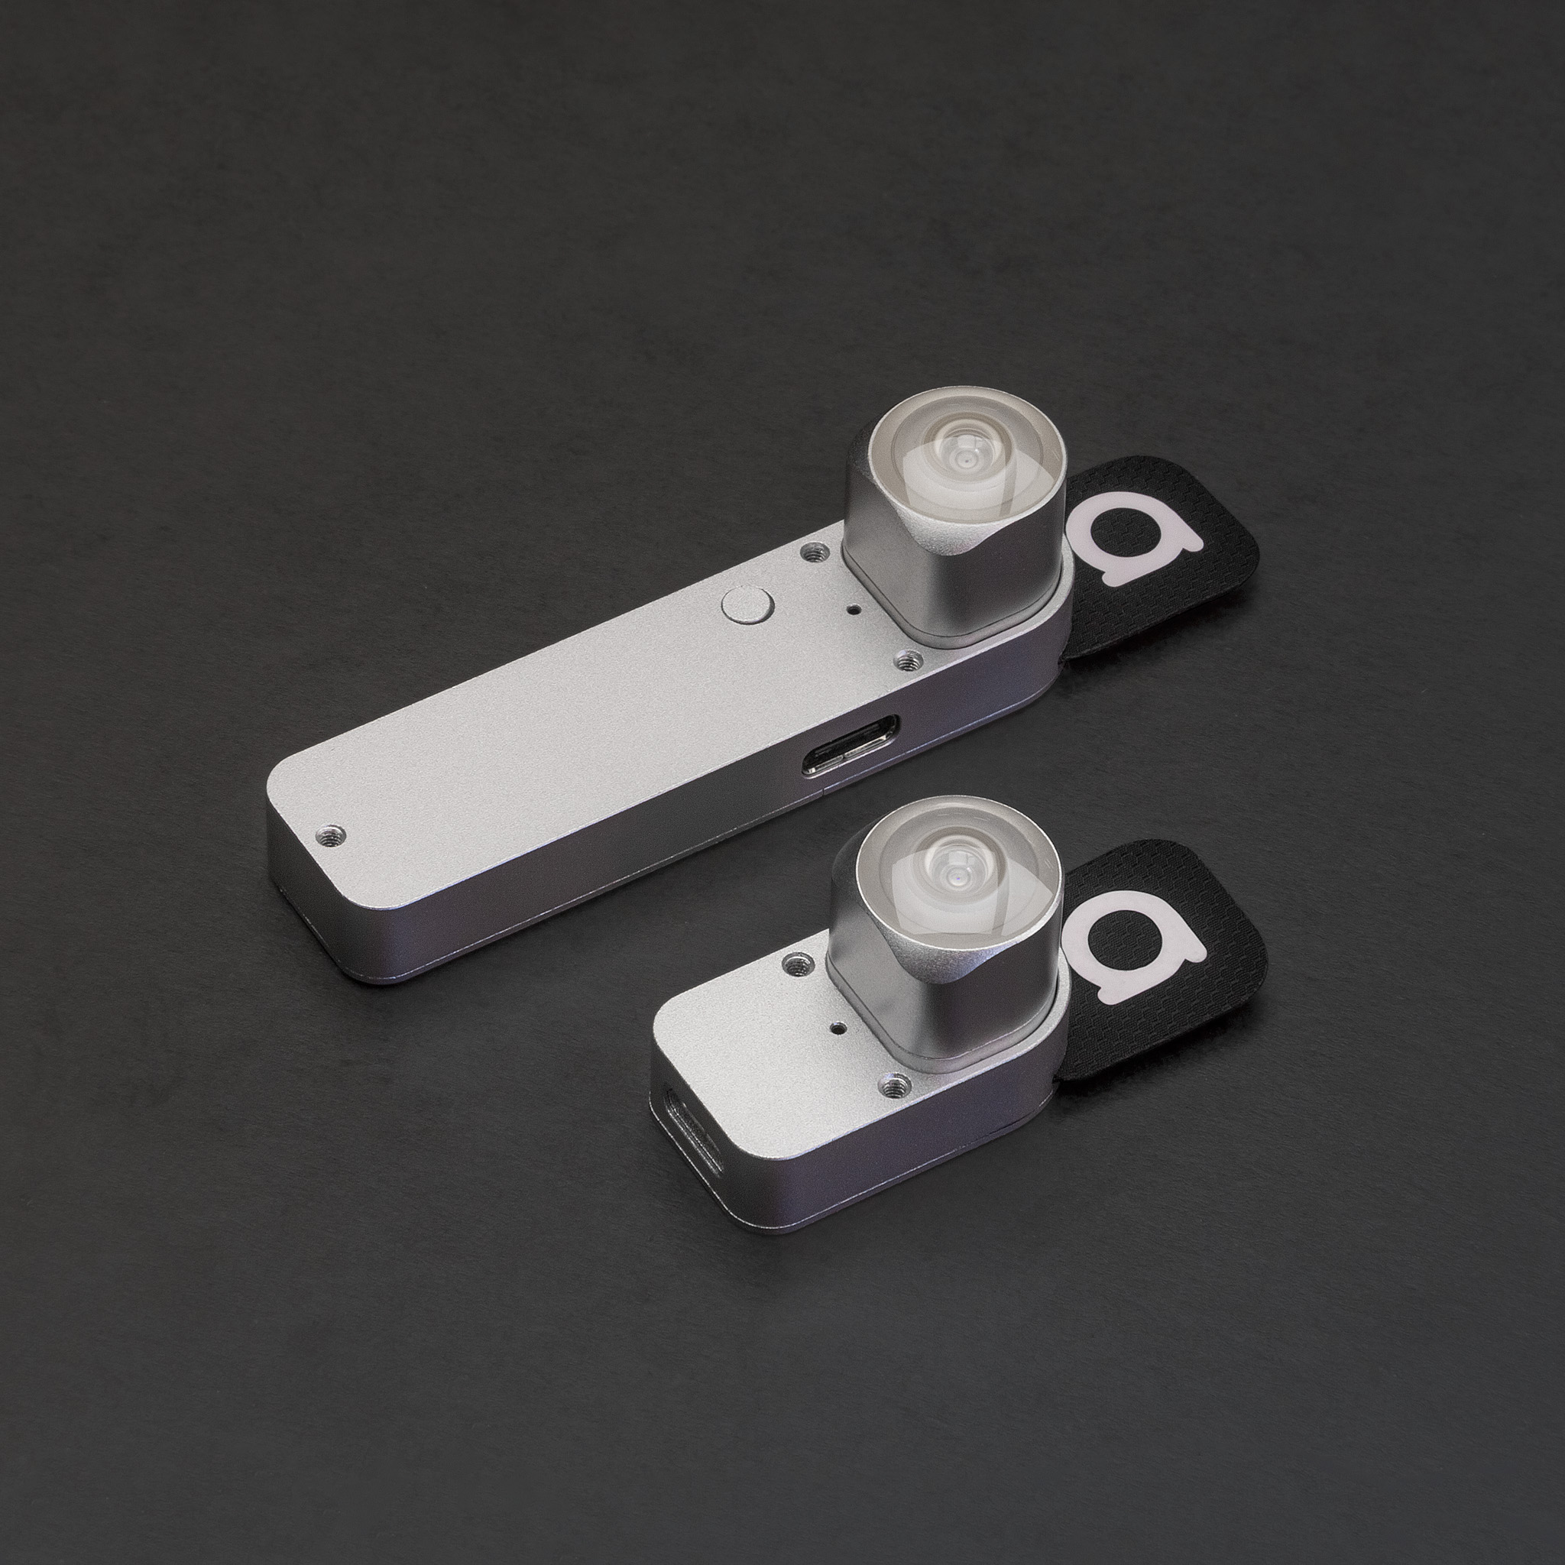

Antilatency [6] is a 6 degree of freedom tracker that utilizes cameras, IMUs, and infrared LEDs to achieve its functionality. These trackers are used within the confines of a floor mat containing LEDs. The camera estimates the tracker’s relative position by referencing the LEDs on the mat, and an IMU estimates the tracker’s absolute rotation. There are wireless and wired versions of the tracker. The benefits of this tracker include extremely precise tracking with minimal latency. The disadvantages of this tracker are the limited mobility space in the tracked area and the loss of positional tracking if any object occludes the LEDs from the camera. Our solution will contain a rigid rotational joint instead of a free-floating point in space. This will allow for constrained joints and structures to be mapped/tracked rather than arbitrary points.

5.2.2 Dexta Robotics Portable Feedback Glove

Dexta Robotics’ Portable Feedback Glove, Dexmo [7] is a force driven haptic feedback glove that is completely wireless, unlike other similar products currently on the market. This glove uses servo motors to provide force feedback along with rotational joint tracking. Dexmo can accurately track all three degrees of rotation of the thumb joint. While this is extremely impressive, it is only useful for the hand. Modeling any other joints is outside the scope of this product. Note that the concept behind Dexmo is based-off the patent in Section 5.1.3 and a paper submitted to CHI in 2016 [8]. The system in [8] stops the rotation of all finger joints simultaneously rather than applying torque control at each individual joint. This design choice allows the device in [8] to be simpler, more affordable, and safer than a design with multiple independent active joint actuators; however, this choice to provide only “binary” haptic feedback also limits the level of immersion experienced by the user.

5.3 Open Source Project Analysis: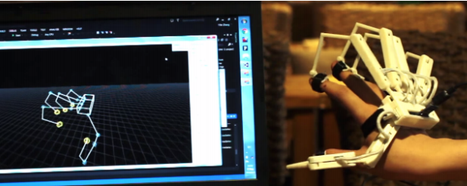

5.3.1 Wireality:

A wearable, string-based, haptic feedback system (coined “Wireality”) was submitted to CHI 2020 [9]. The system features the use of programmatically locking/retractable wires that attach to each finger on one hand to allow for tangible interactions with complex geometries in virtual reality. According to this paper, there has already been significant research on haptic feedback for users’ heads, bodies, and limbs as well as previous research specific to string-based haptic systems. This project’s addition to the current body of research is a “truly wearable and mobile implementation, which delivers haptic feedback to the whole arm and each hand joint independently.” The primary limitation to the Wireality design is its inability to provide haptic feedback in any other direction than perpendicular to the wearer’s torso.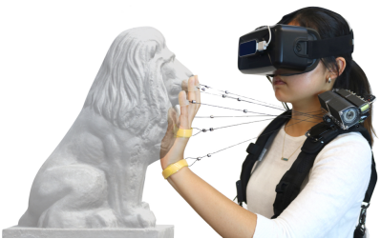

5.3.2 VIDET:

A haptic interface to aid mobility of those who are visually impaired (coined “VIDET”) was submitted to IEEE ICRA 2000 [10]. This system uses stereo cameras to construct a 3D depth map of the surrounding area and then allows the user to interact with the map by using wires to constrain the user’s finger motions according to the depth profile. This project was a pioneering work in the field of string-actuated haptic feedback devices, yet it was highly constrained by the era’s limited computational power and digital camera technology.

6.0 Sources Cited:

[1] P. Sisson, “How VR Training in the Workplace Is Transforming Learning on the Job,” Redshift, 30-Mar-2021. [Online]. Available: <https://redshift.autodesk.com/vr-training-in-the-workplace/>. [Accessed: 09-May-2021].

[2] J. B. Klassen, “Exoskeleton suit with hand control to enable walking,” 06-Aug-2019.

[3] X. Gu, “Hand exoskeleton force feedback system,” 24-Sep-2019.

[4] “Antilatency tracking system for VR/AR,” Antilatency. [Online]. Available: <https://antilatency.com/>. [Accessed: 09-May-2021].

[5] “Touch the Untouchable,” Dexta Robotics. [Online]. Available: <https://www.dextarobotics.com/>. [Accessed: 09-May-2021].

[6] Gu, X., Zhang, Y., Sun, W., Bian, Y., Zhou, D., & Kristensson, P. O. (2016). Dexmo: An Inexpensive and Lightweight Mechanical Exoskeleton for Motion Capture and Force Feedback in VR. CHI '16 Proceedings of the 2016 CHI Conference on Human Factors in Computing Systems, 1991-1995. <https://doi.org/10.1145/2858036.2858487>

[9] CHI '20: Proceedings of the 2020 CHI Conference on Human Factors in Computing Systems April 2020 Pages 1–10. <https://doi.org/10.1145/3313831.3376470>

[10] P. Arcara, L. Di Stefano, S. Mattoccia, C. Melchiorri and G. Vassura, "Perception of depth information by means of a wire-actuated haptic interface," Proceedings 2000 ICRA. Millennium Conference. IEEE International Conference on Robotics and Automation. Symposia Proceedings (Cat. No.00CH37065), 2000, pp. 3443-3448 vol.4, <https://doi.org/10.1109/ROBOT.2000.845258>.

Appendix A: Concept Sketch

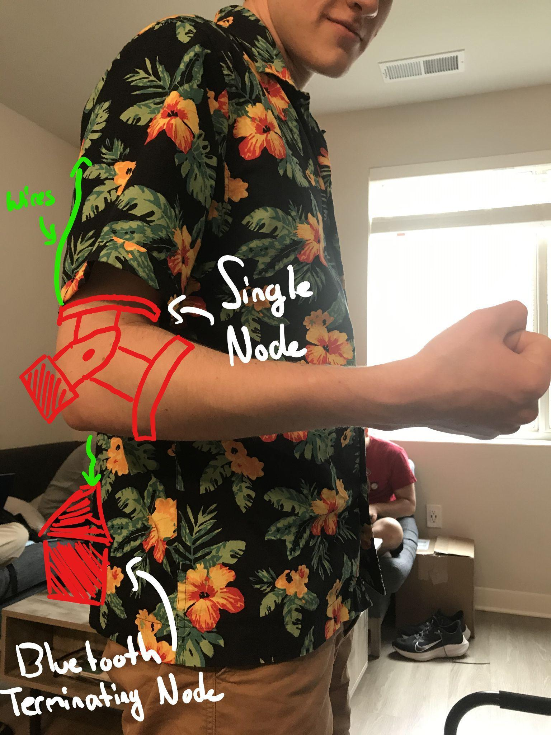

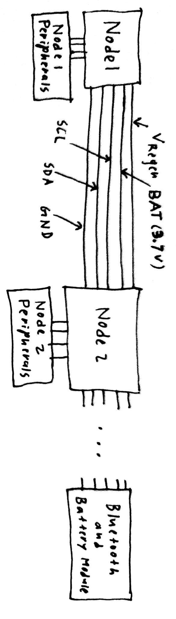

Appendix B: Regenerative Braking Feasibility Analysis

**B.1: Estimation of Sensor Node Power Consumption**

To determine the usefulness of regenerative braking in RevEx, we first estimate the energy requirements of each sensor node. RevEx will use a 1.8 V analog and digital supply rail to minimize static/dynamic power dissipation. The ADC sampling rate will be fixed at 104 Hz when motion is detected. The main contributors to power draw are:

* **The IMU:** *LSM6DSLTR* (always on at a sampling rate of 104 Hz with both the gyroscope and accelerometer enabled [0.7 mW draw])
* **The MCU:** *STM32L081KZT6* @ 16 MHz [HSI] (in stop mode with RTC [2 µW draw] when movement is not detected by the analog event detector and brought to run mode [7 mW draw] with ADC [<25 µW draw at 12 bit resolution] when movement is detected).
  + Since the wakeup time from stop mode is 7 µs (maximum), our device can be put to sleep between sensor system readings (samples are taken roughly every 10 ms). Since we aim to have a maximum of 10 sensors, data acquisition and transmission (occur in run mode) is not expected to take more than 1 ms. Using this “power mode cycling” technique, the MCU power draw while movement is detected will be below 1 mW.
* **The analog antialiasing filters and event detector:** the preliminary design contains 3 quad-channel operational amplifier ICs (discounting any dissipation from passive components and using the *MCP6054* IC, an upper estimate of the quiescent draw is 0.75 mW)
* **The Bluetooth Module:** *CYBLE-416045-02* (in deep sleep mode [20 µW draw] when there is no movement and is transmitting [10 mW draw] only when there is movement)
  + Like the MCU, this too can be cycled between power modes. The wakeup time from deep sleep mode is 50 µs at the maximum. For simplicity, if we use the same timing scheme as we did for the MCU, the power draw when there is movement will be roughly 1 mW.

In summary, the upper power draw estimates for RevEx (after adding a 100% margin for passive component dissipation) are **8 mW** (while the user is actively moving) and **3 mW** (while the user is not moving their arm). Note that our voltage regulator of choice, ADP150, has >95% conversion efficiency in this power range. The goal of energy harvesting (using regenerative braking) is to offset additional current draw while the user is moving their arms to provide a significant increase in battery life.

**B.2 Estimation of Power Generation Via Regenerative Braking**

In a typical RevEx haptic feedback application, regenerative braking is used to bring a free-spinning human arm to a stop. An average person has a mass of 62 kg [B1]; hence, the forearm and hand, which account for 2.3% [B2] of total body mass, have a mean mass of 1.4 kg. An average person has a height of 1.65 m [B3]; hence, the forearm and hand, which are 21.6% [B2] of body height in length, have a mean length of 0.35 m. Taking a uniform rod approximation, the forearm and hand have a moment of inertia ($I$) of 0.057 kg*m2 about the elbow joint. The usable electrical energy harvested by our system is approximated by:

$U=\frac{1}{2}I⋅{\left(\frac{θ⋅π}{180°⋅T_{Ext}}\right)}^{2}⋅η$ (1)

In Equation 1, $θ$, $T_{Ext}$, and $η$ denote the angular range of the arm movement, the time required to execute the movement, and the overall conversion efficiency, respectively. $η=0.1$ is possible with a standard negative-feedback control system [B4]. Hence, if a person moves through the entire range of the elbow (take $θ=120°$) in 1 s, 12 mJ of usable energy can be harvested. 12 mJ is a lower estimate on the energy generation during a typical movement; usually, a user will try to “overcome” the braking effect (haptic feedback), so even more power can be generated [B5].

**B.3 Validation of Estimates Via Experimental Testbench**

The estimations in B.2 are validated experimentally using the testbench in Figure B.3.1. The shaft of a low-profile bipolar stepper motor is turned back and forth with a wrench at varying speeds over an angular range of 120° (roughly the range of the human elbow joint). The EMF generated by the motor is fed to a full-bridge rectifier, and the output of the full-bridge rectifier is fed to a 1 Ω shunt. The voltage drop across the shunt is measured with an Analog Discovery 2 and is analyzed in MATLAB.

|  |  |
| --- | --- |
|  |  |
| (a) | (b) |

**Figure B.3.1:** Validation setup (a) schematic (b) photograph

In essence, the MATLAB algorithm determines how the energy generation during one full extension of an elbow joint depends on the speed/rate of the extension motion. The algorithm does this by squaring the voltage waveform (to determine instantaneous power), computing the analytic envelope of the waveform, thresholding the analytic waveform (to “segment” the large dataset into individual extension movements), and integrating the squared voltage waveform over each segment (to measure the energy dissipation by the shunt over the movement). The analysis algorithm is visually depicted in Figure B.3.2(a), and Figure B.3.2(b) shows a plot of energy generation over an elbow extension vs. extension rate. The most energy is harvested when the motion is fast enough to generate substantial emf (that can overcome the forward voltages of the Schottky Diodes), yet the motion must be sustained (hence the apparent tradeoff in Figure B.3.2(b)). Note that the results are not consistent due to the difficulty in maintaining a steady speed throughout the duration of the motion. Further improvements can be seen with better diode selection and an adaptive electrical load. In fact, there are several ICs on the market that perform maximal power point tracking (MPPT) to adaptively change the loading condition on the energy harvesting system for maximal efficiency.

|  |  |
| --- | --- |
|  |  |
| (a) | (b) |

**Figure B.3.2:** MATLAB analysis (a) algorithm (b) results with “estimated” trend

**A.4 Discussion and Summary**

It was found that RevEx would draw roughly 8 mW (while the user is actively moving) and 3 mW (while the user is not moving). During a 1 s arm motion, 12 mJ can theoretically be harvested using a crude kinematic estimate. We have demonstrated that we can harvest 0.4 mJ - 2.7 mJ using a full bridge rectifier and an energy harvesting circuit equivalent to a 1 Ω load. A more sophisticated energy harvesting circuit can approach the theoretical limit. The end goal is not to power RevEx entirely off regenerative braking but to use regenerative braking to extend battery life; hence, harvesting even 1 mJ per full arm extension is sufficient for our purposes.

**Sources Cited:**

[B1] S. C. Walpole, D. Prieto-Merino, P. Edwards, J. Cleland, G. Stevens, and I. Roberts, “The weight of nations: an estimation of adult human biomass,” BMC Public Health, vol. 12, no. 1, 2012.

[B2] “Body Segment Data,” Exrx.net. [Online]. Available: https://exrx.net/Kinesiology/Segments. [Accessed: 21-May-2021].

[B3] M. Roser, C. Appel, and H. Ritchie, “Human Height,” Our World in Data, 2013.

[B4] S. Derammelaere et al., “ISO efficiency curves of a -two-phase hybrid stepping motor,” in 2010 IEEE Industry Applications Society Annual Meeting, 2010.

[B5] R. Hosoda and G. Venture, “Human elbow joint torque estimation during dynamic movements with moment arm compensation method,” in 19th International Federation of Automatic Control World Congress, 2014, 3rd ed., vol. 47, pp. 12305–12310.